Omnium

Software Design Document (SDD)

Version 1.0
4/3/2026

Release Checklist

Checklist Item | Control (Yes/No)
The document has passed the quality assurance process. | NO
The document is visually appealing and has a professional look and structure. | YES
All placeholders such as text within <> are replaced with appropriate text. | YES
The document is prepared in the “Justify Text” format. | YES
The document does not include typos, different fonts, and misalignments. | YES
In the revision history, the first version states “The first version”. Additional versions include an entry highlighting all the changes from the previous version. | YES
The table of contents (TOC) is updated as necessary. | YES
References list other project documents and additional standards or documents needed to understand the document. The references include the necessary document/artifact version number and publication date. | YES
The language grammar is used appropriately. | YES
Sentences are written as full sentences. | YES
The wording in the document is formal. | YES
The wording in the document is clear. | YES
The wording in the document is professional. | YES
All project-related definitions, acronyms, and abbreviations sections are included in the related tables. | YES
The team member names are specifically spelled out in the document preparation and approvals sections. | YES
The purpose and scope of the document are adequately described. | YES
All sections include the necessary and adequate information. | YES
The design decisions, design constraints, and the related reasonings are written in full sentences. | YES
The system designs are provided in such detail to guide the remaining development process. | YES
The user interface designs are provided in such detail to guide the remaining development process. | YES
The modules are described with adequate descriptions. | YES

Final Control | Yes/No
The document is checked based on the “Team Project Artifacts Common Errors” Guideline. The document is ready for release. | NO
The document is not ready for release. | YES

Document Preparation
Name | Role | Approval (Signature) | Approval Date
Ayesha Khan | Project Technical Manager | Ayesha Khan | 04/03/2026
Andrew Tamez | Project Design Manager | Andrew Tamez | 04/03/2026
Eli Ventura | Project Configuration Manager | Eli Ventura | 04/03/2026
Joseph Duff | Project Requirements Manager | Joseph Duff | 04/03/2026
Michaela Montelongo | Project Quality Assurance Manager | Michaela Montelongo | 04/03/2026
Brady Bottari | Project Test Manager | Brady Bottari | 04/03/2026

Document Approvals
Name | Role | Approval (Signature) | Approval Date
Hector Marrero-Colominas | Project Manager | Hector Marrero-Colominas | 04/03/2026

Revision History
Date | Version | Description | Author
04/03/2026 | 1.0 | The first version | Ayesha Khan  Andrew Tamez  Eli Ventura  Joseph Duff  Michaela Montelongo  Brady Bottari

Table of Contents
1. Introduction 6
1.1 Purpose of the Document 6
1.2 Scope of the Document 6
1.3 References 6
2. Product Scope 7
3. System Design Decisions and Constraints 7
3.1 System Design Decisions 7
4. Software Architectural Design 9
5. Software Design - Modules/Classes 9
5.1 Registration & Login (Authentication) 9
5.2 Database 10
6. User Interface Design 11
6.1 Top Navigation Bar 11
6.2 Ticker Tab Bar 11
6.3 Sidebar Navigation 11
6.4 Dashboard Panel Area 11
6.5 Visual Design Characteristics 11
6.6 Design Rationale 12
7. Appendix A – Class Diagram of the Software System 13
8. Appendix B – User Interfaces 14

Software Design (SDD)

Introduction

Purpose of the Document
The purpose of this document is to document the software design for the project Omnium. It provides a detailed overview of Omnium’s development choices.

Scope of the Document
The scope of this document is to outline the project’s system’s designs and constraints, the software design, and its modules/classes. The document will also provide a look at the user interface design and a class diagram of the software system.

References
Reference Title/Name | Date | Version
Project Description Document | 1/25/2026 | 1.0
Project Vision Document (PVD) | 2/13/2026 | 1.0
Project Plan (PP) | 2/23/2026 | 1.0
Software Requirements Specification (SRS) | 3/2/2026 | 1.0
IEEE/ISO/IEC 29148-2018 - ISO/IEC/IEEE International Standard - Systems and software engineering -- Life cycle processes -- Requirements engineering | 10/23/2018 | 2018
Web Content Accessibility Guidelines (WCAG) | 11/11/2008 | 2.0

Definitions, Acronyms, and Abbreviations

Term | Abbreviation / Acronym | Definition
Omnium | N/A | The modular trading dashboard application that’s being developed in this project.
Paper Trading | - | A simulated trade using real or historical trade data with no risk of financial loss, uses virtual money.
Windows Presentation Foundation | WPF | A Microsoft graphical subsystem used to build Windows desktop applications.
Internet of Things | IoT | A network of physical devices, vehicles, appliances, any physical object with a way to collect and share data.
User Interface | UI | The visual component that allows users to interact with the system.
Project Vision Document | PVD | This document specifies the vision, objectives, and features of Omnium.
Project Plan | PP | This document specifies the plan for the project of developing Omnium.
Software Requirements Specification | SRS | This document specifies the software requirements for Omnium.

Product Scope
Omnium is a desktop-based modular trading dashboard designed to provide users with a structured and configurable interface for monitoring trading-related information and executing analytical decision processes. The system is intended to support users in organizing and interacting with multiple trading decision modules with a unified dashboard environment.

The primary scope of the system includes the development of a modular user interface that supports dynamic module loading, module switching, and interactive dashboard panel management. The system shall provide a structured layout that allows users to navigate decision modules and manage the display of trading-related information.

The system is intended to operate as a Windows desktop application developed using Windows Presentation Foundation (WPF). The architecture shall support modular expansion to allow additional decision modules to be integrated in future releases.

The following items are included within the scope of this product:
- Implementation of a modular dashboard interface.
- Support for switching between multiple decision modules.
- Interactive management of dashboard panels.
- Structured navigation components.
- Integration capability with external data sources through defined interfaces.

The following are currently outside the scope of this version of the product:
- Direct brokerage account transaction execution.
- Mobile platform deployment.
- Real-time financial exchange infrastructure hosting.

System Design Decisions and Constraints

System Design Decisions

System Design Decision ID | Date | Design Decision | Reason
DD-1 | 04/03/2026 | This application will be a desktop application, specifically for Windows systems. | The application will be accessed through desktop only to ensure that the user is able to have all the necessary resources for the application to run. It will only be accessible through Windows, so it can utilize WPF.
DD-2 | 04/03/2026 | The user interface shall use icons and text to keep the user interface simple. | The application will use a simple but comprehensible navigation for the user to access what they need anytime.
DD-3 | 04/03/2026 | The application will use a database to store user data. | The application will extract user data across uses to ensure the users’ information is concise, and the user has the necessary data to access when needed.
DD-4 | 04/03/2026 | The application shall utilize a number of coding languages to bring together the UI and internal process. | The application includes many libraries from different languages such as Python, C#, and MySQL. Python is utilized for the backend development, C# for the graphical user interface, and MySQL for storing the application’s data.
DD-5 | 04/03/2026 | The application will use a simple interface. | The application will utilize a simple graphical style for ease of use and navigation for users.
DD-6 | 04/03/2026 | The application shall have a light and dark mode. | The application is a mobile application that can be used in the daytime and nighttime. Having appropriate modes will help the use of the application.
DD-7 | 04/03/2026 | The application shall use Python libraries for mathematical calculation and machine learning trading algorithms. | The application includes many heavy calculations for machine learning. As Python libraries support many ML implementations, using these libraries will speed up the development.

System Design Constraints

System Design Constraint ID | Date | Constraint | Reason
DC-1 | 04/03/2026 | The application shall provide both simplified and advanced user interface modes to accommodate beginner and experienced traders. | The system must serve a diverse user base; beginners require guided and intuitive interfaces, while experienced traders require advanced tools and customization for effective simulation.
DC-2 | 04/03/2026 | The application shall require an active internet connection for accessing updated market data and syncing user progress. | Realistic simulation depends on up-to-date data feeds and cloud synchronization, which cannot be reliably maintained in a fully offline environment.
DC-3 | 04/03/2026 | The application shall securely store user data, including account information and trading history, using encryption mechanisms. | User data protection is essential to prevent unauthorized access, ensure privacy, and maintain user trust in the platform.
DC-4 | 04/03/2026 | The application shall process and display simulated market data with near real-time performance, maintaining minimal latency during trade execution and chart updates | Day trading decisions depend heavily on speed and timing; therefore, delays in simulation could lead to unrealistic training conditions and reduce the effectiveness of the platform.

Software Architectural Design
The software architecture of the Omnium application is described in this section.

Software Design - Modules/Classes

Module/Class Name | Module Short Name (If there is one) | Short Description of the Module/Class
Registration & Login | Authentication | This class is responsible for creating a new user account with a unique username, and unique email if chosen. Login will log in an existing user. Email authentication is active for both. If a user chooses to add an email, they will be required to enter the random code sent each time at registration or login.
Database | DB | This class is responsible for retrieving financial stock data via Yahoo! Finance and storing it in a database schema, as well as storing user account information.
Security Search | Search | The search module is responsible for locating assets by entering the company name or ticket symbol.
SonarQube | SonarQube | The SonarQube module is responsible for providing code checks on the developers’ IDE and GitHub pull requests, as well as providing relevant data through its web GUI.
Profile Logging | Profile Logging | This module is responsible for keeping track of all the trades that users make on their account to give a thorough overview of their account history and value.

Registration & Login (Authentication)
The registration and login class shall authenticate users who are registering or logging into Omnium. It is the first action a user must take in order to be able to access Omnium.
Attributes:
- Username: A unique value that each user must enter and will identify the user. Must be at least 3 characters long and include no blank spaces.
- Password: A value that has parameters to ensure security strength. Must be at least 6 characters long, have one uppercase letter and one digit.
- Email: An optional value, used to increase security of account if chosen to add. One unique email per account.
- Verification Code: A 5digit random code sent to the email attached to an account. Used to verify registration and login
- User Lockout: If a user fails to login 3 times, user is locked out their account for 60 seconds.
Methods:
- Register: Will allow a user to create a new account. Requires a unique username, a password, and adding an Email is optional.
- Login: Will allow returning users to login to their previously created account. If an Email was added during registration, it will send the user a 5 digit code to verify it is their email.
- Email Adding: Will ask at account registration if user wants to add an email address to their account. If yes, user enters their email and will receive a 5 digit code in the email used to verify access to it.
- User Lockout: User will have 3 attempts to login to their account, receiving an error each time. If user fails to sign into their account 3 times, user will be locked out for 60 seconds. Once 60 seconds are over, user can retry logging in.

Database
This class contains the database schema and modules for retrieving, managing, and processing financial stock data. In addition, it also manages a database table that stores the users registered to Omnium.
Attributes:
- Assets: This is a table which stores the symbol and name attributes of any given company from the Dow Jones Industrial Average index.
- Symbol: This is a string that stores the ticker symbol associated with a particular company.
- Name: This is a string that stores the official name of the company represented by the ticker symbol.
- Prices: This is a table which stores value attributes related to the price of any given company’s securities.
- Timestamp: This stores a datetime index of a particular asset’s price at some given point in time.
- Open: This float stores the value of open, which is the first executed trade price in a day for a given asset.
- High: This float stores the highest priced stock of a given day.
- Low: This float stores the lowest priced stock of a given day.
- Close: This float stores the final price at which a stock is traded during a given day.
- Volume: This float stores the total number of shares bought and sold of a security on a given time period.
- Account: This table stores the user’s account information, their email address, and encrypted password.
- Created_At: This is a datetime index that stores the time when a users account was created.
- Cash_Balance: This is a float which stores the virtual currency associated with a user’s account.
- Side: This is a string which stores whether a security is “buy-side” or “sell-side”.
- Quantity: This is an int which stores the quantity of a given asset.
- Price: This is an int which stores the price of a given asset.

Methods:
- Insert Asset: This method will retrieve a company’s name and ticker symbol from the Yahoo! Finance API and store it into the Assets table.
- Insert Price: This method will retrieve a company’s assets and store it as a new row in the Prices table.
- Insert Trade: This method will retrieve information about a user’s trades and store it into the Trades table.
- Get Asset by Symbol: This method will return an asset that matches an input query of a company’s ticker symbol.
- Get Latest Price: This method will return the most recent price record of an asset, which shall include the Timestamp, Open, High, Low, Close, and Volume attributes.
- Get Price History: This method will return the historical stock record of an asset, which shall include the Timestamp, Open, High, Low, Close, and Volume attributes.
- Get Account: This method will return details about a user’s account, which shall include the Cash_Balance and Created_At attributes.
- Create User: This method will insert a new entry into the Accounts table when a new user account is registered.

User Interface Design
The user interface of the Omnium system is designed to provide a structured, modular, and user-friendly trading dashboard environment. The interface is organized into multiple distinct regions to ensure clarity, usability, and efficient interaction with the system components.\
The user interface is composed of the following primary elements:

Top Navigation Bar
The top navigation bar is positioned at the upper section of the application window. It is used to display system-level information and provide access to global system functions. The bar includes elements such as account information, ordered management access, and system status indicators. Critical values, such as profit and loss, are displayed to ensure that users can continuously monitor important metrics.

Ticker Tab Bar
The ticker tab bar is located directly below the top navigation bar. It is used to manage multiple trading contexts within the system. Each tab represents a specific financial asset, identified by its ticker symbol. The user is able to switch between tabs to view different datasets and decision modules. The interface supports the dynamic addition and removal of tabs, allowing users to customize their workflow.

Sidebar Navigation
A vertical sidebar is provided on the left side of the interface. The sidebar is used to access key system functionalities, including watchlist management, asset search, and decision module selection. The layout of the sidebar is designed to minimize visual clutter while maintaining accessibility. Each navigation option is clearly labeled to improve usability.

Dashboard Panel Area
The central portion of the interface is dedicated to the dashboard panel area. This area contains modular panels that display various types of trading-related data and tools. Each panel is designed as a reusable component with a consistent structure, including a header section and content section.
The system supports dynamic interaction with panels. Panels may be repositioned within the dashboard using drag-and-drop functionality. The layout follows a grid-based structure to maintain alignment and organization. This design allows users to configure the dashboard according to their analytical needs.

Visual Design Characteristics
The user interface utilizes a dark-themed color scheme to reduce eye strain during extended usage. A gradient background is applied to enhance visual depth. Panels include borders and subtle shadow effects to distinguish them from the background.
Interactive elements, such as buttons and tabs, provide visual feedback when selected or hovered over. These visual cues improve user awareness of system interactions.

Design Rationale
The design of the user interface is based on the following principles:
- The interface shall provide a clear separation between navigation components and data display areas.
- The interface shall support user customization through modular panel management.
- The interface shall maintain consistency across all components to improve usability.
- The interface shall support scalability to allow future integration of additional modules.
These design principles ensure that the system remains flexible, maintainable, and easy to use.

Appendix A – Class Diagram of the Software System
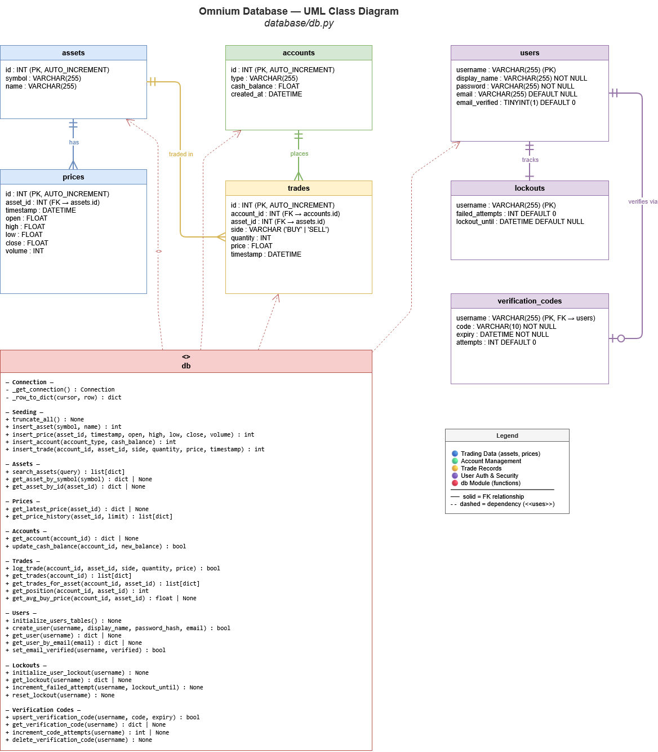

Appendix B – User Interfaces
Following are some user interface pictures of the system:

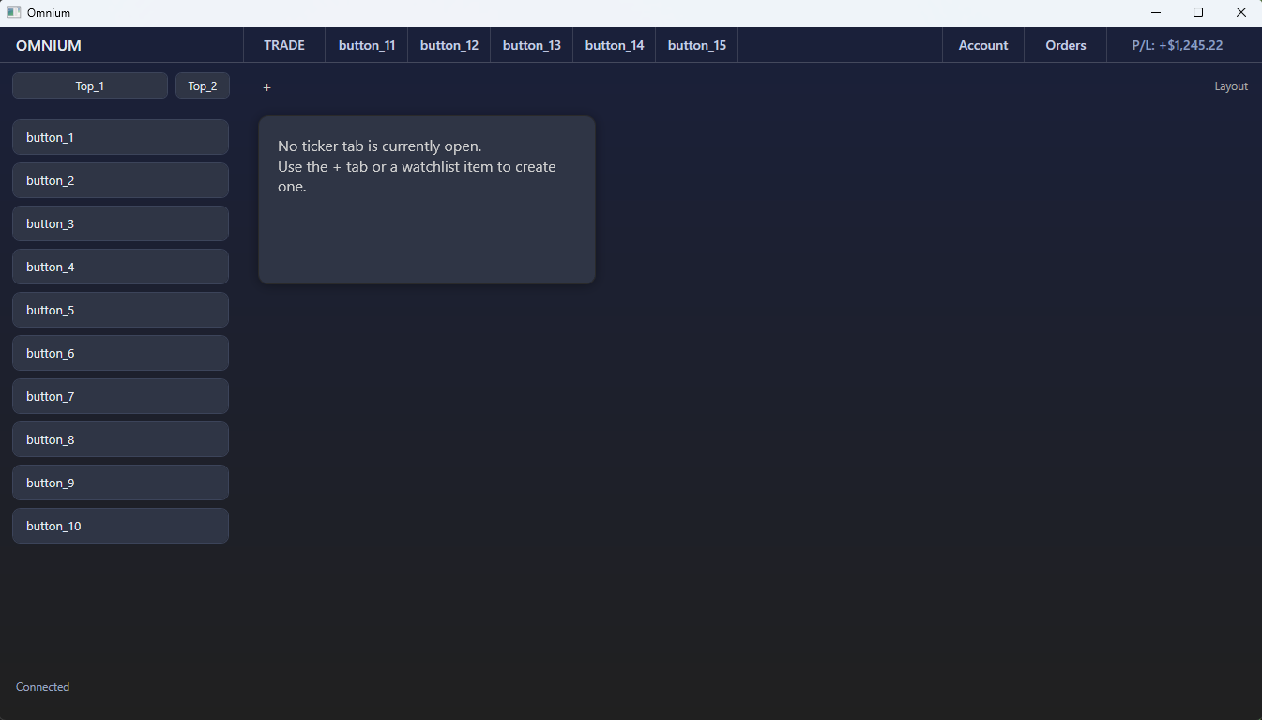
Figure 1: Fresh Dashboard With No Active Panels
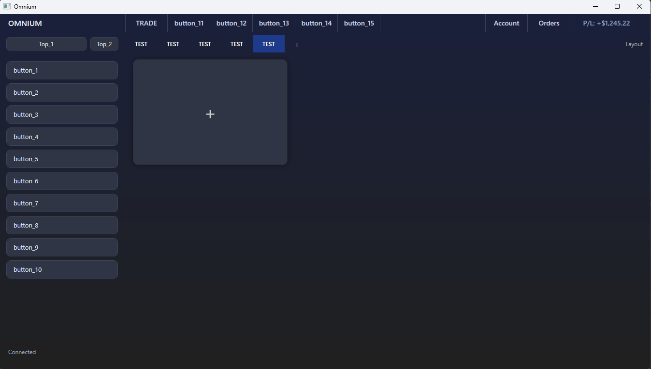
Figure 2: Dashboard of Omnium With 1 Blank Panel and 5 TEST Ticker Tabs

